Planning Services
Gateway Determination Report

LGA | Mid Coast
RPA | Mid Coast Council
NAME | Stage 2 Northern Gateway Hub (119 jobs)
NUMBER | PP_2017_MCOAST_09_00
LEP TO BE AMENDED | Greater Taree LEP 2010
ADDRESS | Emerton Close and Denison Street Cundletown
DESCRIPTION | Lot 1 DP 1098686, Lot 1 DP 733715, Lot 2 DP 733715, Lot 16 DP 613107, Lot 681 DP 617842, Lot 1 DP 1139255
RECEIVED | 31/10/2017
FILE NO. | 17/03148
QA NUMBER | Doc/A3993691
POLITICAL DONATIONS | There are no donations or gifts to disclose and a political donation disclosure is not required
LOBBYIST CODE OF CONDUCT | There have been no meetings or communications with registered lobbyists with respect to this proposal

INTRODUCTION

Description of Planning Proposal
The planning proposal seeks to facilitate the development of Stage 2 of the Northern Gateway Transport Hub and protection of ecologically sensitive areas of the site. The Proposal will rezone approximately 67 hectares of land at Cundletown to IN1 General Industrial Zone, E2 Environmental Conservation Zone and E3 Environmental Management zone, amend the minimum lot size for the IN1 zoned land and amend an existing local provision so as to apply to the land and require additional consideration of the impact of future development on the provision of flood free land for agriculture
Council advises that development of the Northern Gateway Hub (Stages 1 and 2), has the potential to create 119 jobs.

Site Description
The site is generally flat, largely cleared and identified by Council as low hazard flood fringe. It is currently used for agricultural purposes and rural living with rural dwellings and agricultural structures across the site. The ecological study has identified areas of Endangered Ecological Communities in part of the site (north-west and south-east) and the nest of a Threatened Species, Eastern Osprey, towards the centre of the site.

Surrounding Area
The site is located between the airport and the northern access to the Pacific Highway at Cundletown. It is adjacent to a reserved corridor for the Cundletown bypass. The site has been identified by Council as a strategic location for a transport hub due to its proximity to the regional Sydney – Brisbane Transport Corridor. The rezoning of Stage 1 was supported by the Department in 2015 and finalised in August 2016. Council has subsequently approved development of Stage 1 in May 2017. Stage 2 lies further away from the Highway towards the airport and is a large parcel of undeveloped, flood free land.

Locality map showing areas associated with zone amendments.

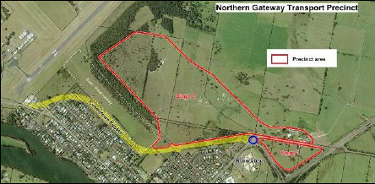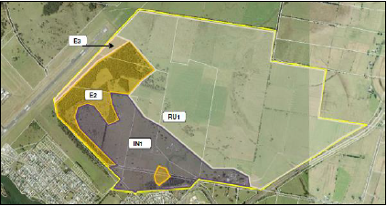
Figure 1: Northern Gateway Transport precinct Figure 2: Stage 2 Planning Proposal
(Greater Taree City Council 2016) (Mid Coast Council 2017)

Summary of Recommendation
It is recommended that the Planning Proposal proceed subject to conditions.

PROPOSAL

Objectives or Intended Outcomes
The Planning Proposal states that the key objective is to develop the Northern Gateway Transport Hub, generating employment and providing the opportunity to improve the movement of freight within the locality. The proposal also seeks to rezone environmentally sensitive portions of the site for environmental purposes, this is not specifically mentioned within the objectives.

Explanation of Provisions
The Explanation of provisions clearly explains the proposed changes including to;
- rezone approximately 67 hectares of land at Cundletown from RU1 Primary Production to IN1 General Industrial Zone, E2 Environmental Conservation Zone and E3 Environmental Management zone;
- amend the minimum lot size to reduce the minimum lot size that applies to the IN1 zoned land to 2 hectares, retaining a 40 hectare minimum lot size on all other land; and
- amend an existing local provision (7.10 Greater Taree LEP 2010) so as to apply to the subject land and require additional consideration of the impact of future development on the availability of flood free land for agriculture. The provision applies to future development applications and currently requires consideration of their impact on the operation of the site as a Freight Hub.
Mapping
The submitted planning proposal includes mapping suitable for the purposes of community consultation. Mapping consistent with Departmental requirements will be prepared following a Gateway Determination.
NEED FOR THE PLANNING PROPOSAL

The planning proposal is the result of Council’s long term vision for the establishment of a Transport Hub in this locality. Council identifies that this vision has been reflected in the draft Greater Taree Conservation and Development Strategy 2005, draft Manning Valley Local Strategy 2016, draft North Coast Regional Plan 2016 and now superseded Mid Coast Regional Plan 2006-2031.

No strategic study or report has been provided specifically for the Northern Gateway Transport Hub. In the absence of a strategic study or report it is not possible to determine that the scale and irregular footprint of the proposed IN1 zone is suitable for a transport hub, however further investigation into the development potential of the site through a Planning Proposal is considered appropriate. A Planning Proposal that rezones the land is required to facilitate the proposed development.

STRATEGIC ASSESSMENT

Regional
Hunter Regional Plan 2036
Although not specifically identified within the Hunter Regional Plan, the proposal is broadly consistent with the directions and actions of the Plan. In particular the Plan recognises the potential for economic development to leverage off both the Pacific Highway and Taree Airport (Direction 4 – Enhance inter-regional linkages to support economic growth and Actions 4.1 and 4.6 and Direction 6 – Grow the economy of MidCoast and Port Stephens and Action 6.4 specifically).

The MidCoast narrative specifically makes reference to “develop opportunities to cluster appropriate economic activities around the Taree Airport and Pacific Highway interchanges (Northern Gateway and Manning River Drive) that support the ongoing commercial and retail role of Taree CBD”.

Local
There is no finalised strategy within the Mid Coast Council area that specifically identifies the site for a transport hub. Council notes several draft Strategies that have identified future employment or industrial land in the locality including the draft Greater Taree Conservation and Development Strategy 2005 and the draft Manning Valley Local Strategy 2016, neither strategy has been finalised or endorsed by the Department.

Section 117(2) Ministerial Directions
The Planning Proposal is inconsistent with or potentially inconsistent with the following s117 directions and further consultation is required before this can be assessed;

  - Mining, Petroleum Production and Extractive Industries: The rezoning of the land for industrial development will restrict mining and the potential development of resources. Consultation with the Department of Primary Industries is required before consistency or otherwise with this direction can be determined. This consultation is required as a condition of the Gateway determination.

2.1 Environment Protection zones: The proposal includes provisions that facilitate the protection and conservation of environmentally sensitive areas of the site. Whether or not this addresses all environmentally sensitive areas of the site, or if not whether inconsistency with the direction can be justified, needs to be determined through consultation with the Office of Environment and Heritage. This consultation is required as a condition of the Gateway determination.

4.3 Flood Prone Land: Portions of the site proposed to be rezoned IN1 General Industrial are identified as below the flood planning level as defined by the Greater Taree LEP 2010, with flood planning levels in the planning proposal based on the Manning River Flood Study 2016. The proposal is inconsistent with this direction and no floodplain risk management plan has been prepared for the site. Council has indicated that this inconsistency may be justified because a Floodplain Management Plan is expected to be in place by the time a development application for this site is considered and that some filling and land form modification will occur as part of future development. Due to the extent of land affected, including small portions by high hazard, consultation with Office of Environment and Heritage is recommended.

In addition consultation with the Office of Environment and Heritage, NSW Rural Fire Services and the Civil Aviation Safety Authority is required to clarify consistency or otherwise with s117 directions 2.3 Heritage Conservation, 3.5 Development Near Licenced Aerodromes and 4.4. Planning for Bushfire Protection.

The inconsistency with the following s117 directions is considered justified for the reasons described below;

1.2 Rural zones: The proposal seeks to rezone rural land to industrial and is therefore inconsistent with this direction. The Department of Primary Industries did not raise concerns with the proposed Industrial zoning however were concerned about the alienation of the productive flood prone agricultural land. Council has indicated that the inconsistency with this direction is justified because the proposal is consistent with the Hunter Regional Plan. Council has proposed the inclusion of a clause that facilitates access to the higher value land and ensures the availability of low flood risk land for agricultural use. It is recommended that the delegate of the Secretary agree that the inconsistency is justified as of minor significance because the land of highest production value is being retained, with the ongoing productivity of this land being facilitated by the local provision.

6.3 Site Specific Provision: Council proposes the amendment to an existing clause to apply site specific provisions to this site and is therefore inconsistent with this direction. Council have proposed this amendment to address the concerns of the Department and Department of Primary Industries in relation to preventing the sterilisation of the remaining flood affected agricultural land by maintaining access to low flood risk land. This site specific provision is not expected to unduly constrain development of the site for the purpose for which it is intended and therefore it is recommended that the delegate of the Secretary agree that the inconsistency is justified as of minor significance.

The Planning Proposal is consistent with all other relevant s117 directions, in particular it is considered consistent with direction 1.5 Rural Lands and the Rural Planning Principles and Rural Subdivision Principles of the Rural Lands SEPP that this direction refers. The proposal protects opportunities for current and potential productive economic activities in the rural area and balances the social, economic and environmental interests of the community. The proposal also minimises rural land fragmentation and rural land use conflicts and proposes to respond to the natural and physical constraints and opportunities of the land.

State Environmental Planning Policies
Several SEPP’s identified by Council are relevant or potentially relevant to future development of the site, including State Environmental Planning Policy No 33—Hazardous and Offensive Development and State Environmental Planning Policy (Exempt and Complying Development Codes) 2008, these SEPP’s will be considered as part of any future development assessment.

SEPP’s relevant to the planning proposal include State Environmental Planning Policy No 44—Koala Habitat Protection (SEPP 44), State Environmental Planning Policy No 55—Remediation of Land (SEPP 55), State Environmental Planning Policy (Rural Lands) 2008 (SEPP Rural Lands), State Environmental Planning Policy No 71—Coastal Protection (SEPP Coastal).

SEPP 44 – SEPP 44 applies to the land via schedule 1 with the listing of the former Greater Taree LGA. Council’s assessment has identified the presence of koala feed trees on the site and undertook further investigation. This investigation did not identify any evidence of resident koala populations or koala sightings despite historical records of a population. Further investigation into any necessary clearing can occur through development assessment. The land contains potential koala habitat but not core koala habitat and there is nothing within the SEPP that precludes the planning proposal.

SEPP 55 – Council identifies the potential contamination of the site as a result of historical agricultural use and the need for further investigation to determine the extent of contamination and any remediation required. The need for this investigation has been identified as a condition of the Gateway determination and this will clarify consistent or otherwise with the SEPP.

SEPP Rural Lands – The proposal is consistent with SEPP Rural Lands as per the discussion in relation to the s117 directions 1.2 Rural Zones and 1.5 Rural Lands.

SEPP Coastal - The south western parts of the site are located within the coastal zone all be it at some distance away from the coastal foreshore (1km from the Manning river and 9km from the coast). The location of the proposal on the outskirts of town does not necessarily promote compact towns and cities however is an appropriate location given the future proposed use and proximity to key transport infrastructure. Visual amenity and biodiversity conservation are to be addressed through the development control plan and future development assessment. The proposal is not inconsistent with the SEPP.

SITE SPECIFIC ASSESSMENT

Social
Council identifies that the social benefits of the proposal include potential job creation and the opportunity to improve the movement of freight within the locality, reducing heavy vehicle loads on local roads through the diversion of traffic to the freight hub. These benefits will be clarified through a detailed traffic assessment undertaken to support any future development of the site.

The subject land is separated from existing residential development by the proposed Cundletown bypass and Council intends to require vegetated screening through the development control plan to manage any impacts on amenity.

Council indicates that an AHIMS search has been undertaken and no Aboriginal sites or places were identified. Council has also indicated that further Aboriginal heritage investigation and assessment will be undertaken following Gateway determination. No evidence of European heritage has been identified on the site.
Environmental
Biodiversity
The flora and fauna assessment has identified high value Endangered Ecological Communities that are unable to be offset offsite in parts of the north west and south east of the site. The proposal seeks to zone these communities to E2 Environmental Conservation. The proposal also seeks to zone additional vegetation, not investigated as part of the Flora and Fauna Assessment, to the same zone. Council has advised that this extension was agreed by the applicant after a site inspection with Council’s environmental officer.

The flora and fauna assessment has also identified the nest of an Eastern Osprey (state listed vulnerable species and commonwealth listed migratory species) towards the centre of the site. A standard buffer of 100 metres and zoning of E2 Environmental Conservation has been considered however Council wish to explore passive or active relocation. Consultation with the Office of Environment and Heritage regarding this approach is recommended as a condition of the Gateway determination.

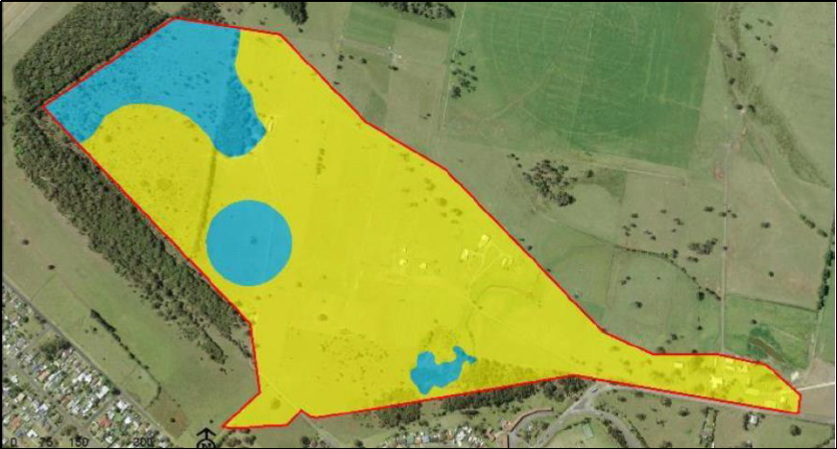

Figure 3: Important ecological values (blue) and potential land for development (yellow)

Council has also proposed rezoning rural land adjacent to the airport to E3 Environmental Management. The land is largely cleared, Council has advised that they have selected the zone because it complimented the adjoining land in the E2 zone and allowed regular maintenance to reduce vegetation for airport safety. Council indicated that they have used the E3 zone, not to reflect any environmental use, but rather as managed land between potentially conflicting land. In this case the zone would act as a buffer between vegetated lands and the Taree Regional Airport. In the circumstances the use of the E3 zone for this purpose cannot be supported. In the absence of the need for management of environmental values, the use of an E zone for this ‘buffer’ purpose is not consistent with policy as outlined in the Department’s practice note Environment Protection Zones PN 09-002. It is recommended that the Gateway determination be conditional upon council identifying a more suitable alternate zone for this land, potentially retaining the RU2 rural landscape zone.

Flooding
Portions of the site are identified as below the flood planning level as prescribed by the Greater Taree LEP 2010. Council proposes to rezone some of this flood affected land to IN1 General Industrial and argues that it is low hazard flood fringe and that it is likely that some filling and land form modification will occur as part of future development.

In the absence of a concept plan detailing the distribution of development across the site or the nature of that development, and given the extent of land affected, consultation with Office of Environment and Heritage regarding the need for any further investigation into this flood hazard at this point in time is recommended.

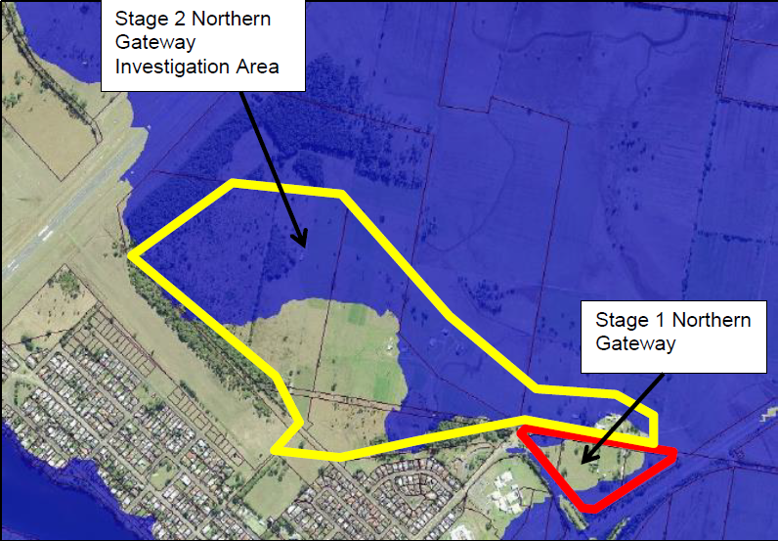
Figure 4: Flood Planning Level (1% AEP with 2100 plus 0.5m freeboard)

Bushfire
Parts of the western edge of the site are identified as Bushfire Prone Land and consultation with the NSW Rural Fire Services will be recommended as a condition of the Gateway determination.

Economic
The Planning Proposal indicates that an economic assessment of the Northern Gateway Transport Hub has been undertaken and identifies that it could provide for an additional 119 jobs in the locality and approximately $42 million of additional output. A copy of the economic assessment hasn’t been provided however it is agreed that the proposal, when developed, would yield positive economic benefits for the area.

Infrastructure
Due to the scale of the proposal and proximity to state roads, any future development of the site may require resolution of the provision and funding of state road infrastructure. The Gateway determination is conditional upon consultation with RMS to ensure that any issues associated with the rezoning of the land, including the need to map the site as an urban release area, are resolved prior to exhibition.

Council has indicated that discussions have been held with Mid Coast Water and work will be required to connect the site to the necessary services. A water and sewer servicing strategy will need to be prepared to accompany any future development application. Mid Coast Water has recently merged with MidCoast Council, and the water and sewer servicing strategy still needs to be prepared.
CONSULTATION

Community
Council proposes a public exhibition period of 28 days in accordance with Council’s Advertising and Notification Requirements and the Department’s ‘A guide to preparing local environmental plans’. A notification period of 28 is supported, given the scale of the proposal.

Agencies
Council has already undertaken consultation with the Department of Primary Industries regarding impacts on agriculture. Council proposes to consult with the following agencies;
- Roads and Maritime Services – traffic and access issues
- Office of Environment and Heritage – Aboriginal cultural heritage and ecological issues
- Department of Primary Industries – mining and extractive industries
- NSW Rural Fire Service
- Mid Coast Water within MidCoast Council

TIMEFRAME

Council proposes an ambitious timeframe of 9 months to finalise the Planning Proposal. Due to potential delays to the required investigations and consultation over the Christmas New Year period a timeframe of 12 months has been recommended.

DELEGATION
Council has not sought plan making delegations in relation to this proposal because they are a landowner of a small portion of the land subject to the proposal. In the circumstances it is recommended that delegation not be issued.

CONCLUSION

The Planning Proposal is supported to proceed with conditions

RECOMMENDATION

It is recommended that the delegate of the Secretary:
- Agree any inconsistencies with Section 117 Directions 1.2 Rural zones and 6.3 Site Specific Provision are minor or justified; and
- Note that the consistency with Section 117 Directions 1.3 Mining, Petroleum Production and Extractive Industries, 2.1 Environment Protection zones, 2.3 Heritage Conservation, 3.5 Development Near Licenced Aerodromes, 4.3 Flood Prone Land and 4.4. Planning for Bushfire Protection are unresolved and will require further consideration.

It is recommended that the delegate of the Minister for Planning, determine that the planning proposal should proceed subject to the following conditions:

- Prior to public exhibition Council is to review the proposed E3 Environmental Management zoning, which is not supported, and select a zone consistent with Departmental guidance on the application of Standard instrument zones.

- Prior to exhibition consultation is required with the following public authorities for the purposes described below and their advice is to be incorporated into the Planning Proposal, including any amendments to the proposed mechanism.

  - Office of Environment and Heritage – Regarding s117 direction 2.1 Environment Protection zones, 2.3 Heritage Conservation and 4.3 Flood Prone Land, including the proposed management of the Eastern Osprey Nest.
  - Roads and Maritime Services – Regarding traffic and access issues and the need for the site to be identified as an urban release area for the purpose of state contributions.
  - NSW Rural Fire Service – Regarding consistency or otherwise with s117 direction s117 4.4. Planning for Bushfire Protection

- The planning proposal, amended development control plan and any relevant studies and documentation should be made available for community consultation for a minimum of 28 days.

- Consultation is also required with the following public authorities, this may occur during public exhibition:

- Department of Primary Industries (mining and extractive industries) - Regarding s117 direction 1.3 Mining, Petroleum Production and Extractive Industries
- Mid Coast Water – regarding servicing
- Civil Aviation Safety Authority regarding s117 direction 3.5 Development Near Licenced Aerodromes.

- The timeframe for completing the LEP is to be 12 months from the date of the Gateway determination.
- Given the nature of the planning proposal, Council should not be authorised to exercise delegation to make this plan.

10/12/2017
Robert Hodgkins Monica Gibson
Team Leader, Hunter Director Regions, Hunter
Planning Services

Contact Officer: Katrine OFlaherty
Director Regions, Western
Phone: 0428 268 311

